IIIF and Data Modeling

# IIIF (International Image Interoperability Framework)

Briefly…

* <http://iiif.io/>
* Community focused on interoperability and reuse of images, primarily in the cultural heritage sector
* Developed set of complementary specifications: Image API (image delivery behavior), Presentation API (enough structural and descriptive information to drive a viewer for humans), Search API (to search content of annotations, transcriptions, OCR text, etc. within an object)

# IIIF Presentation API

<http://iiif.io/api/presentation/2.1/>

* Consider scope: <http://iiif.io/api/presentation/2.1/#objectives-and-scope>
  + The display of digitized images associated with a particular physical object, or born-digital compound object.
  + Navigation between the pages, surfaces or views of the object.
  + The display of text, and resources of other media types, associated with the object or its pages – this includes descriptive information about the object, labels that can aid navigation such as numbers associated with individual pages, copyright or attribution information, etc.
  + **The following are not within scope:**
    - The discovery or selection of interesting digitized objects is not directly supported; however hooks to reference further resources are available.
    - Search within the object is not supported by the Presentation API
* Descriptive metadata does not have semantic meaning intentionally - everything is treated as a label.[1]
* Multiple viewers exist that can work with IIIF Presentation API resources:
  + Mirador - <http://projectmirador.org/>
  + Universal Viewer - <http://universalviewer.io/>
* Developer-friendly JSON serialization, but leverages JSON-LD to implement an RDF model

## Review of IIIF Presentation API model

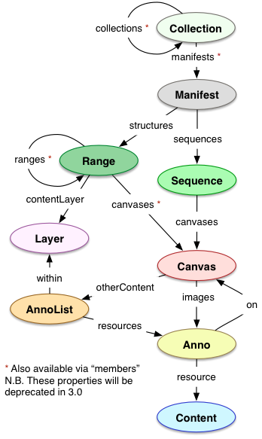

Remember: a Collection contains only Collections or Manifests

A minimally "useful" and valid IIIF Presentation API object should:

* have a Manifest w/ 1..∞ Sequences,
* where a Sequence has 1..∞ Canvases,
* where a Canvas has 1..∞ images,   
   associated as Annotations
* where an (image) Annotation is only  
   associated with 1 Image Resource.

Ranges can help provide additional structural information, e.g. to drive tables of contents

# IIIF manifest example (more than one image)



Postcard from James Broughton to William D. Judson

Carnegie Museum of Art

[Link to object](http://records.cmoa.org/things/466b0c8a-e1fc-48a0-80c9-370c725cb25e/)

[Link to IIIF manifest](http://cmoa-records-images.s3.amazonaws.com/fv001_001_003_001_B004_F09_002/manifest.json)

# Next steps

* Create your group's model in Google Drawings or on the provided easel pad paper
* What would be minimally sufficient for the reference object? <http://bit.ly/HC16DataModelExample>
* What would provide improved access?
* If time, imagine there were additional resources like a transcription - how would you relate them?

1. For more information on IIIF and descriptive metadata interoperability, see [https://docs.google.com/presentation/d/1Ku8TVc_JS4ptwf5Ts4r3I2vXZ-q66GLkO5QT8xww21I/edit](https://docs.google.com/presentation/d/1Ku8TVc_JS4ptwf5Ts4r3I2vXZ-q66GLkO5QT8xww21I/edit?usp=sharing)